Map reading skills 1: Conventional signs and map interpretation

1 What does the conventional sign represent on a 1:5,000 map?
A A temple
B A library
C A playground
 |  | D | A declared monument
D

2 What does the conventional sign represent on a 1:20,000 map?
A A house
B A post office
C A police station
 |  | D | A fire station
C

3 Refer to the photograph below.
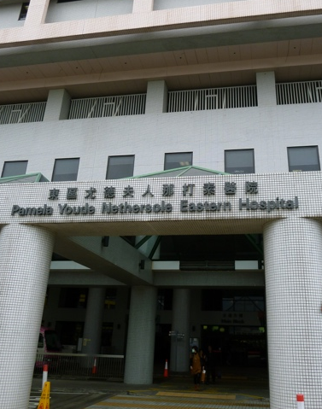
(Credit: Dltl2010/Wikimedia Commons)
Which of the following is the conventional sign used to represent the above building on a
1:5,000 map?
A
B
C
D
A

4 Refer to the photograph below.
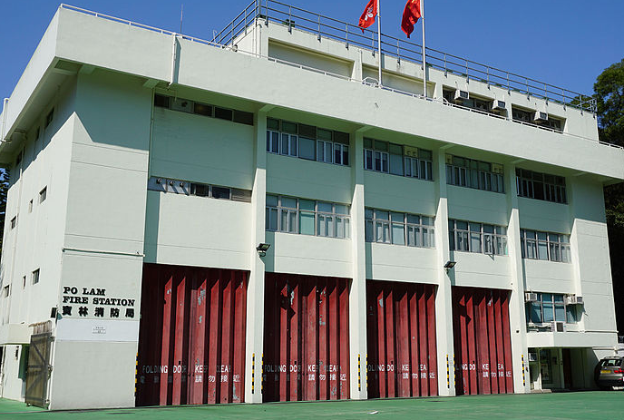
(Credit: Exploringlife/Wikimedia Commons)
Which of the following is the conventional sign used to represent the above building on a 1:20,000 map?
A
B
C
D
B

5 Refer to the map below.
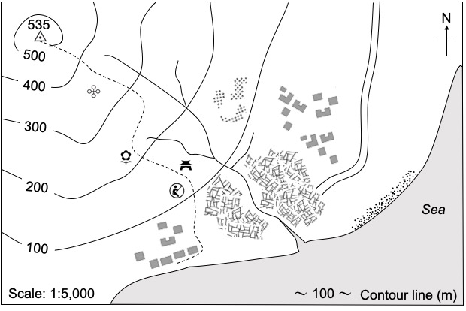
Which of the following features can be found along the footpath?
- A park
- A playground
- A Tze Tong
A 1 and 2 only
B 1 and 3 only
C 2 and 3 only
 |  | D | 1, 2 and 3
A

6 Refer to the map below.
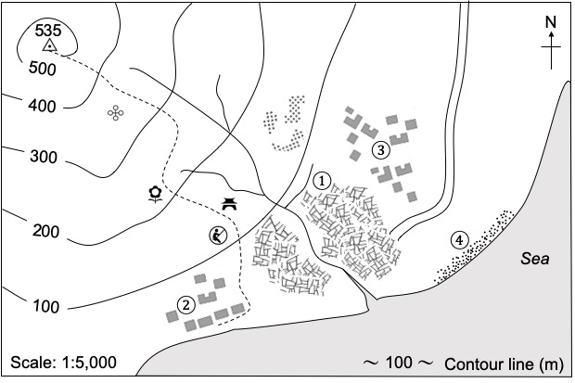
Which of the following places shows agricultural land use?
A Place ①
B Place ②
C Place ③
 |  | D | Place ④
A

7 Refer to the map below.
Which of the following are good reasons to develop agriculture here?
- There is a river providing irrigation water.
- There are settlements providing labour.
- Farm produce can be transported to markets easily by road.
A 1 and 2 only
B 1 and 3 only
C 2 and 3 only
 |  | D | 1, 2 and 3
D

8 Refer to the map below.
What evidence shows that people living here have low incomes?
1 Presence of farmland
2 Presence of village-type houses
3 Presence of temporary structures
A 2 only
B 3 only
C 1 and 2 only
 |  | D | 1 and 3 only
B

