Map reading skills 2: Grid reference, latitude and longitude

1 Refer to the figure below.
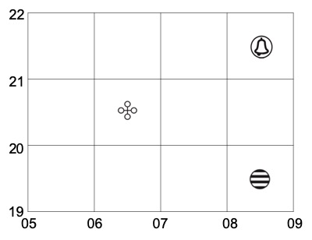
Where can we find a declared monument?
A 0521
B 0620
C 0721
 |  | D | 2006
B

2 Refer to the figure below.
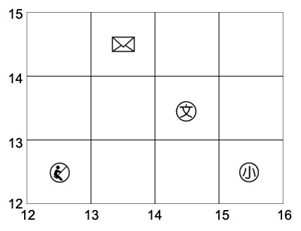
Where can we find a special school?
A 1212
B 1314
C 1413
 |  | D | 1512
C

3 Refer to the figure below.
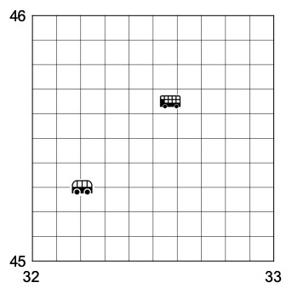
What is the six-figure grid reference of the bus terminus?
A 321453
B 325456
C 453322
 |  | D | 456325
B

4 Refer to the figure below.
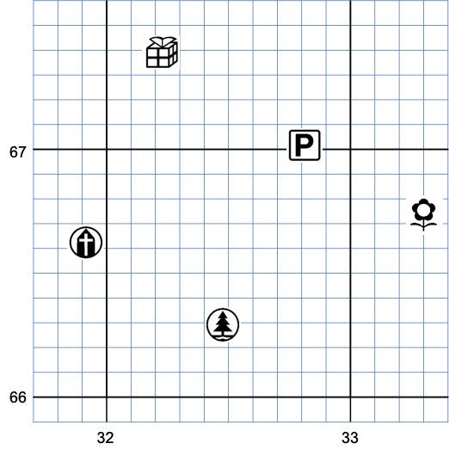
What is the six-figure grid reference of the park?
A 324662
B 325663
C 332668
 |  | D | 333667
D

5 Refer to the figure below.
What is the six-figure grid reference of the car park?
A 327699
B 327671
C 328699
 |  | D | 328670
D

6 Refer to the figure below.
What is the six-figure grid reference of the church?
A 319666
B 319665
C 320666
 |  | D | 320667
A

7 Which of the following descriptions are correct?
1 All the lines of longitude are of the same length.
2 All the lines of latitude are of the same length.
3 The Prime Meridian is located at 0° longitude.
A 1 and 2 only
B 1 and 3 only
C 2 and 3 only
 |  | D | 1, 2 and 3
B

8 Refer to the figure below. Which of the following lines of latitude is the Tropic of Capricorn?
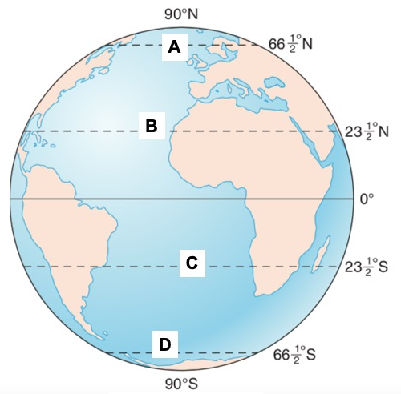
C

